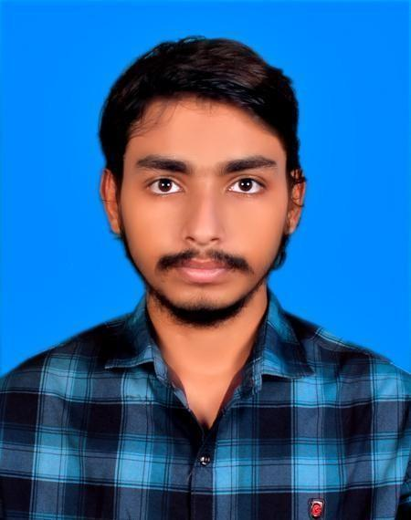
MD JAHANGIR ALAM

Address : 1 Ibrahimpur, Mirpur 14 Email : mdsohagr3665@gmail.com Phone : +880 1756 252604
Date Of Birth : 17 May 2001 Nationality : Bangladeshi

Personal
Statement ———————————————————————————————————
I am a reliable and friendly person who wants to work as a Customer Service Executive. I can talk to customers clearly and help them with their questions on social media like Messenger, Instagram, and WhatsApp. I can process orders carefully and follow up with customers to check if they are happy. I work well in a team and can help with simple office tasks. I am hardworking and always try to give good service to every customer.

EDUCATION AND
TRAINING ———————————————————————————————————
[ 2026 ] Bachelor of Science in Computer Science and Engineering
Presidency University Address : Dhaka, Bangladesh CGPA - 3.58

[ 2019 ] Higher Secondary Certificate (H.S.C) Shahid Bulbul Government College Address : Pabna, Bangladesh
GPA - 5.00

[ 2017 ] Secondary School Certificate (S.S.C) Santhia Pilot High School, Pabna Address : Pabna, Bangladesh
GPA - 5.00

EXPERIENCE —————————————————————————————————
| Database Developer (Academic) | University Management System
Tech Stack : PostgreSQL, DBeaver, ER Diagram
Method : Architected Relational Schema, 3NF
Queries : Developed SQL queries, Stored Procedures, and Triggers
Operations : Integrated CRUD Operations

| Teacher | Tutor At Junior School

| Client Relations Officer | Gorillamove
Role : Worked as Customer Service Executive for 6 Months

SKILLS ———————————————————————————————————
Web - HTML, CSS, JS, API, Next js, N8N Automation |
OOP - Java |
Database - PostgreSQL |
API - Postman, Rest Assured, CRUD Operations |

Microsoft Office |
AI - ML, DL, CNN |
Programming - C, CPP, Java, Python (Numpy, Pandas, Matplotlib, Scikit-learn |
Touch - Typing |

Interest —————————————————————————————————
Problem Solving Competitive Programming
Learning New Technology

LANGUAGE ———————————————————————————————————
Mother tongue(s) : Bengali
Other language(s) :
English
LISTENING C1 READING B2 WRITING B1
SPOKEN PRODUCTION B1 SPOKEN INTERACTION B1

CERTIFICATIONS —————————————————————————————————
Math Olympiad | National Numbers Carnival 2025
| Runners Up - Inter University Programming Contest (2024)
| Bangladesh Math Olympiad (BDMO) 2024
| Math Club
| Robotics Club

